Print Established Report

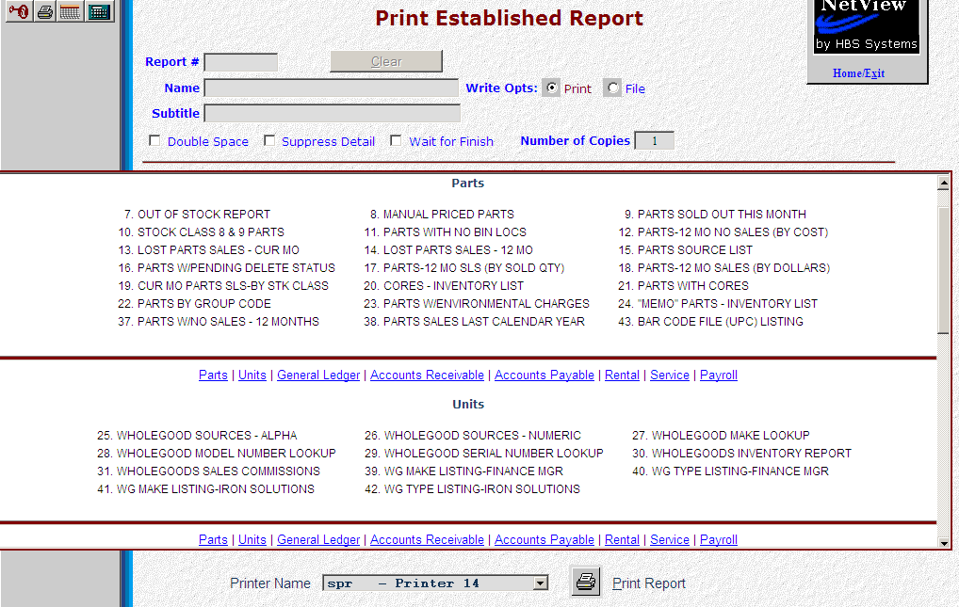

Print an Established Report (PER) lets you print any of the reports present in Report Writer. The package comes with 40-50 base reports, and your dealership can create more. The numbers of the established reports will vary from one system to another, as they are assigned in the order in which they are created. NOTE: If you create a report with linked fields, the report will appear in the category for the field you started with (Ex: if you started in Parts to link a field to AR, the report will be under Parts here).

- To access this function:
  - Select “Report Writer” from the menu, then click the subcategory “Print an Established Report.”
  - Type “PER” in the Shortcut bar.

Field Definitions

Report #:

Enter the number of the report to print.

You may also choose the report from the list shown in the center section of the screen. They are sorted by the package they apply to.

To advance to a specific package’s reports, click on the package name. The packages are:

Parts

Units

General Ledger

Accounts Receivable

Accounts Payable

Rental (Classic only)

Service (Classic only)

Payroll

CRM.

Clear: Click “Clear” if you have selected a report, but want to print a different one.

Name: The name of the selected report will display here.

Write Opts:

Print
  - Click “Print” to print the report.
  - Select the name of the printer or output option from the drop-down menu at the bottom of the screen.
    - Use the “see – Display” option to display the report on your screen.
    - You may select “pdf—Display” to send the report to an Adobe pdf file, which can be viewed, saved, or emailed.
    - Choose “rtf—Word Document” open the report in Microsoft Word.
    - Choose “excel—Excel Document” to send the report to an Excel spreadsheet.
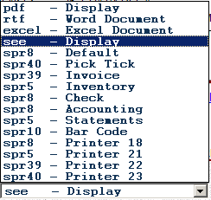

File: This option sends the report to a file on the UNIX system using the output options from the “Printer” drop-down menu. We recommend using one of the print options in lieu of this choice.

Subtitle (Optional): This field shows additional information, if entered.

Double Space: Click the box to double-space the printout, or leave blank for default single-spaced printing.

Suppress Detail: This choice gives you the ability to limit your report to totals and/or subtotals.

Check the box to ensure your report will not show any matching detail items, but only the subtotals and totals for the report.

Leave the box blank to see all the detail items selected for your report.

Wait For Finish: This choice holds the screen while the report is prepared.

If the box is checked, the report’s progress will show on the screen as it is prepared.

If the box is left blank, the report is run and generated in the background.

Number Of Copies: This field defaults to 1, but you may change it to generate additional copies of the report.

Print Report: Click “Print Report” (or type Alt P) to print the report.

Sample Reports:
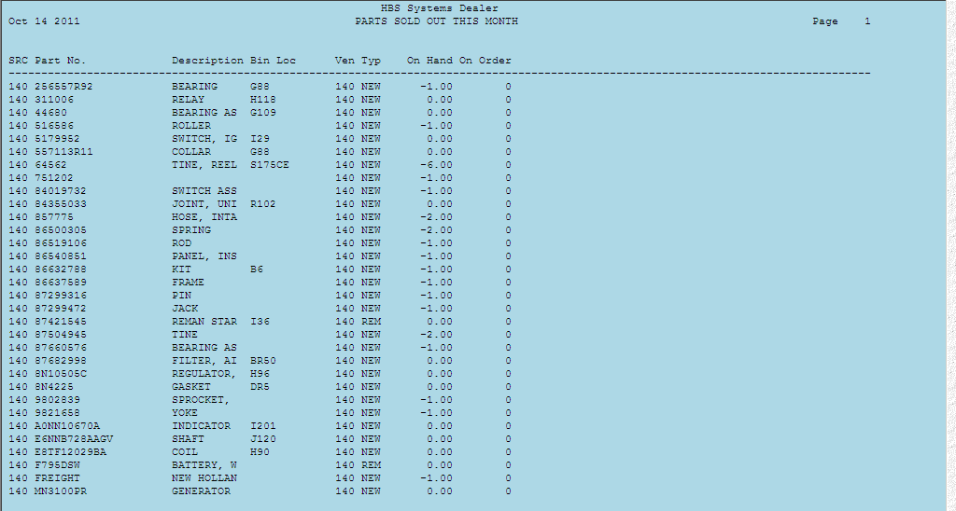
Sample report using “see - Printer.”
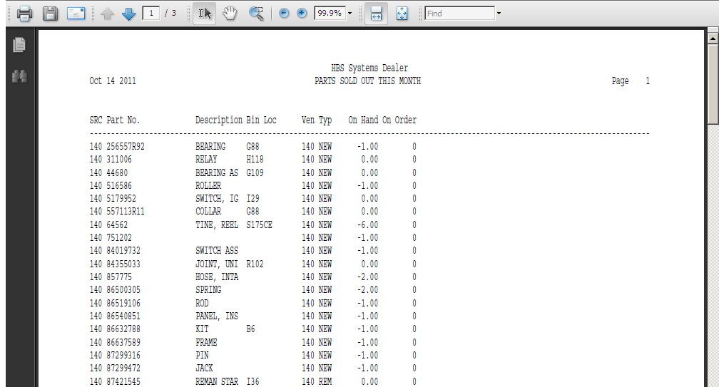
Sample report using the pdf printer option.
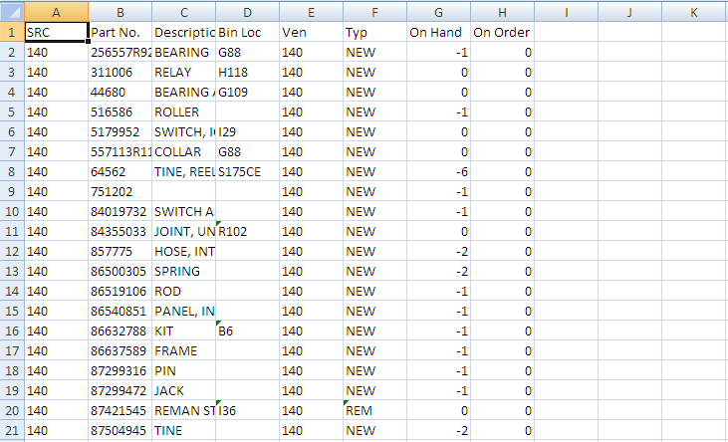
Sample Report using the Excel printer option.

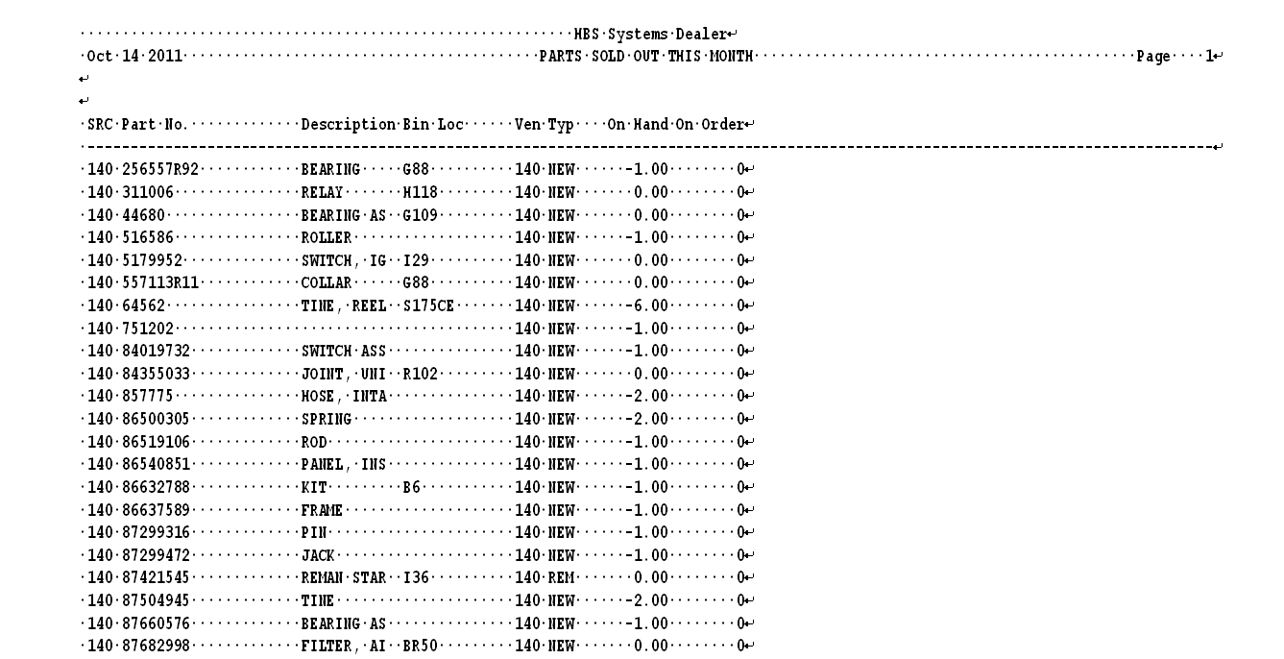
Sample Report using the rtf printer option.

Printing Reports with Prompts: Some Report Writer reports need additional information when they run. In this case, you are presented with one or more options when you run them. The selections screen looks like this:
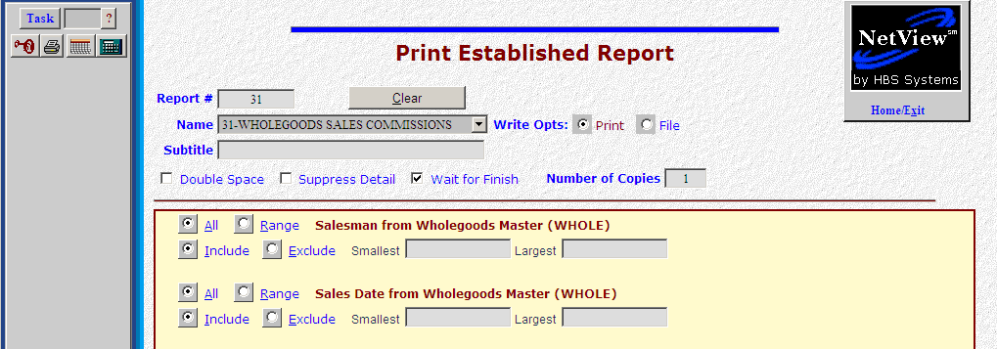
The first prompt in this example is for “Salesman.” It is defaulted to “All,” but you can choose “Range” and then specify a range of values to include or exclude on the report.
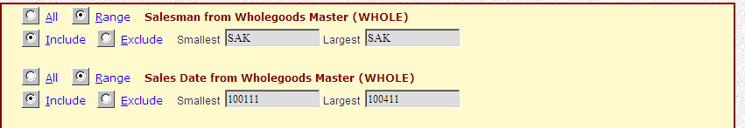
The above example shows selections made for 2 different prompts on a report. The first is a single “Salesman” to include and the second is a date range of “Sales Dates.” Notice the format of the dates entered are “mmddyy” for each, no dashes or slashes.
